DISTRACTED BEHAVIOR TASK FORCE
Consensus Statement
July 18, 2016

Strategy for Reducing Distracted Behaviors:
Pedestrian and Driver

hosted by
West Virginia University Injury Control Research Center
West Virginia UniversityGreater Morgantown Safe Communities Initiative

About the Distracted Behavior Task Force Consensus Development
The Distracted Behavior Task Force (DBTF) Consensus Development Conference was convened to review current literature, policies, and interventions related to distracted behavior while engaging in personal transportation activities. The resultant Consensus Statements are intended to advance understanding of the technology or issue in question and to be useful to health professionals and the public for the purpose of reducing injuries and deaths.
DBTF Consensus Statements prepared by invited stakeholders from law enforcement, governmental safety agencies, municipalities, epidemiology, student leaders and public health were based on (1) presentation by an epidemiologist working in areas relevant to the consensus questions during a 1-day session, and (2) statements and anecdotal evidence derived from task force attendees during open discussion periods. This statement is an independent report of the DBTF consensus panel and is not a policy statement of the West Virginia University, City of Morgantown, Monongalia County and the West Virginia Governor’s Highway Safety Program.

DBTF Consensus Statement

July 18, 2016
Erickson Alumni Center

Strategy for Reducing Distracted Behaviors:
Pedestrian and Driver

This statement reflects the panel’s assessment of current statistical information available at the time the consensus statement was written as it relates to morbidity and mortality associated with behavior while engaging in personal transportation activities. In addition, at the time of the writing of the statement there were minimal data available regarding the efficacy of programs and interventions that prevent or reduce the negative outcomes of distracted behavior. As evidence accumulates through investigations and program evaluation, recommendations within this statement may be adapted to reflect current research.

Disclosure Statement

All of the panelists who participated in the DBTF conference and contributed to the writing of this consensus statement were identified as stakeholders in improving community safety. Panelists were selected for their expertise in their specific domain of driver and pedestrian safety with no known financial or scientific conflict of interest.

Abstract

Objective
To ascertain if distracted behavior using a cell phone precipitates injury or death occurrences while driving or walking, if this behavior is a significant safety concern to the community-at-large and what current evidence-based interventions are available that will reduce the impact of distracted behavior.

Panelists
The individuals participating in this conference were a 15-member panel with expertise in the fields of law enforcement, injury control, public health, epidemiology, public works, engineering, wellness and student government.

Evidence
The current statistical evidence on distracted driving behavior and the impact was provided through a literature search using multi-databases and an extensive bibliography of references was provided to the panel. The epidemiologist prepared presentation provided panelists with relevant citations from the literature. Scientific evidence was given precedence over anecdotal evidence.

Consensus Process
The individuals participating on the panel answered questions related to anecdotal evidence as well as evidence provided through scientific inquiry and developed their conclusions based on the scientific evidence presented to the panel and available scientific literature. The panel read a draft statement that was prepared within 4 days of the meeting and circulated to the panel members via email for comment. Thereafter, the panel resolved conflicting recommendations and released a revised statement at the conclusion of the electronic (email) participation. The panel finalized the revisions within a week upon the completion of the open comment period. The consensus statement was made available for media release immediately following the approval of all panel members.

Conclusions
The collective data continue to support the need for additional and accurate data from national, state and local sources to clearly define the impact of distracted behavior related to pedestrian and motor vehicle injuries and deaths.

The current data suggests that distracted behavior is a significant threat to safety and the threat may be understated due to insufficient data.

Experimental trials should be designed with the appropriate metrics to accurately measure the impact of distracted behavior on personal and community safety. Until data establishes significant relationships, it will be difficult to determine the most effective interventions.

Introduction

Many tasks are attempted while individuals are driving motor-driven vehicles and ambulate. It appears that the cell/smart phone and functions related to its operation pose the most significant distraction to driving and walking. The number of electronic devices and technology related to the use of the device to complete other tasks continues to increase. The following are the most current data:

NATIONALLY -
- Distracted driving (DD)
  - Stats for DD likely under-estimated
  - In 2014, 3,179 killed & 431,000 injured in DD crashes¹
  - 2014 national survey (self-reported behavior)
    - 36% read text, 27% sent text, 69% talked, 17% used internet past 30 days⁴
  - 2014 national survey (road-side observation)
    - 4% of drivers held phone, 2% manipulated phone⁵

WEST VIRGINIA (Distracted Behavior) –
- Distracted walking statistics are unknown
- Drowsy driving
  - For 2008-2009, 2% of fatal crashes (FARS)
  - Injuries unknown
- Distracted driving
  - 2008-2014, 0.4% of fatal crashes (FARS)
  - Injuries unknown
- Road-side observed cell phone use while driving
  - National Occupant Protection Use Survey 2008-2013 (Fig.1)
  - WV Electronic Communication Device Law (2012)

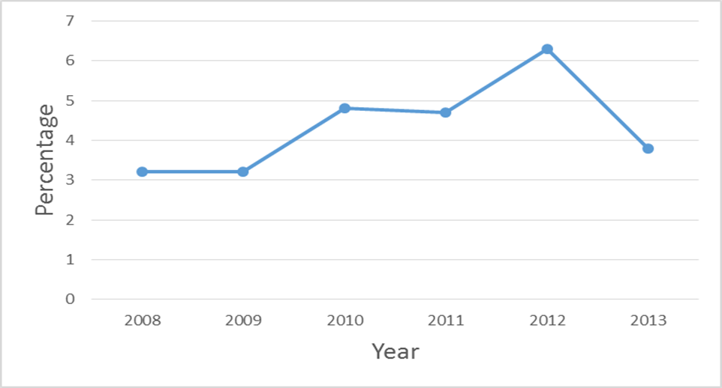
Fig. 1

Evidence-Based Interventions

There are very few evidence-based interventions that significantly reduce distracted driving. Currently, the only interventions that have demonstrated minimal to moderately effective results are the following:

- Technological Interventions
  - Cell phone apps to curb distracted walking/driving⁷
    - Not thoroughly tested
- Engineering Interventions
  - Lighted/signalized, zebra crosswalks ^{8,9}
  - Rumble strips⁶
  - Active prompts near parking garages¹⁰
- Enforcement
  - High visibility enforcement does work in short term⁶
- Behavioral Interventions
  - Email-based education to increase pedestrian compliance at x-walks¹¹
    - mildly effective

  - Education campaign for hospital employees at U of Az¹²
    - Very effective to reduce DD (53%); included posters, survey, pamphlets
  - Fear-evoking DD advertisements¹³
    - mixed results
  - STAR campaign for pedestrian safety @ VaTech¹⁴
    - Reduced pedestrian-vehicle incidents; included pledges, brochures, posters, prizes, and shirts/buttons
  - ITCANW8 campaign for texting while driving @ Bemidji Uni. in MN¹⁵
    - Mildly effective; included pledges, fear advertising, health fashion

Summary

Data available, at the time of the development of the consensus statement for distracted behavior, was deemed inadequate to clearly define the significant impact upon safety. However, the current data suggests that this behavior contributes to a significant number of injuries and death, and strategies to reduce the impact of cell/smart phone use should be addressed.

Consensus Statement - Recommendations

Panel Recommendations for Action
- Well-designed experimental trials which evaluate the number of injuries and deaths related to cell/phone use.
- Well-designed experimental trials which evaluate effective interventions to reduce the impact of cell/smart phone use.
- Develop behavioral interventions effective in reducing injuries and deaths related to cell/smart phone use.
- Prioritize the development of behavioral interventions related to distracted walking to reduce pedestrian injuries and deaths.

Additional Panel Recommendations for Action
- Develop educational programs to prevent injuries and deaths related to cell/smart phone use for pK-12, higher education, and community-at-large.
- Create a “Safety Town” complex for educating pK-12 students on relevant and current safety issues.
- Sponsor a community-wide, technological challenge for the development of technology to reduce injuries and deaths related to cell/smart phone use while driving, walking or cycling.
- Create cell/smart phone “pullover zones”. Promote through media outlets and street level marketing, e.g., “Text Stop Ahead”, “Talk Spot Stop”. Designate reserved parking areas for cell/smart phone use and install signage in strategic areas within the community.
- Install signage on interstates entering West Virginia related to cell/smart phone use. (e.g. Maryland)
- Sponsor challenges to the community-at-large regarding solutions for distracted walking:
- “Create-a-thon” - sponsor a weekend where participants would come and develop their ideas for 36-48 hours; a panel of community members would judge their Distracted App or technologic product; Apps or technologic products would not have to be completed, but in a developmental stage. (e.g. Safe Walking App)
- Top creations would receive awards. (e.g. monetary, scholarships, etc.)

DBTF Consensus Statement Development Panel

Daniel Shook, Ph.D. - Director
WVU-Greater Morgantown Safe Communities
Morgantown, WV

Sheena Sayres, MPH
WVU Injury Control Research Center
Morgantown, WV

Herb Linn - Deputy Director
WVU Injury Control Research Center
Morgantown, WV

Toni Rudisill, Ph.D.
Epidemiologist
WVU Injury Control Research Center
Morgantown, WV

Capt. Harold Sperringer
Assistant Chief
Morgantown Police Department
Morgantown, WV

Lt. Matt Solomon
Morgantown Police Department
Morgantown, WV

Chief Ed Preston
Morgantown Police Department
Morgantown, WV

Julie Merow - President
Student Government Association
West Virginia University

Lisa Hall
WV Governor’s Highway Safety Program
Clarksburg, WV

Tyler Brewster
Board of Directors - Member
Student Government Association
West Virginia University

Robert Bossarte - Director
WVU Injury Control Research Center
Morgantown, WV

Damien Davis - Director
Public Works and Engineering
City of Morgantown

Chief Bob Roberts
WVU Police Department
Morgantown, WV

Amy Boggs
WV Governor’s Highway Safety Program
Charleston, WV

Jolene Willard
WV Governor’s Highway Safety Program
Charleston, WV

Dave Harshbarger, MS, CWP
Wellness Manager
WVU Medicine
WVU Health Sciences

Sgt. David Wilfong
Monongalia County Sheriff Department
Morgantown, WV

Janey Cink
Health Sciences Communications
University Relations
WVU School of Public Health
West Virginia University

Literature

1. National Highway Traffic Safety Administration. Facts and statistics. Available at: http://www.distraction.gov/stats-research-laws/facts-and-statistics.html. Accessed July 11, 2016.
2. Pew Research Center. More than half of cell owners affected by ‘distracted walking’. Available at: http://www.pewresearch.org/fact-tank/2014/01/02/more-than-half-of-cell-owners-affected-by-distracted-walking/. Accessed July 1, 2016.
3. Nasar JL, Troyer D. Pedestrian injuries due to mobile phone use in public places. Accid Anal Prev, 2013. 57: 91-95.
4. AAA Foundation for Traffic Safety. 2014 Traffic Safety Culture Index. Washington DC: AAA Foundation for Traffic Safety, 2015.
5. National Highway Traffic Safety Administration. Driver electronic device use in 2014. Washington DC: Department of Transportation, 2015.
DOT HS 812197.
6. National Highway Traffic Safety Administration. NHTSA drowsy driving research and program plan. Washington DC: Department of Transportation, 2016. DOT HS 812252.
7. Wang T, Cardone G, Corradi A, Torresani L, Campbell A. Walk Safe: a pedestrian safety app for mobile phone users who walk and talk while crossing roads. Presented at Hot Mobile Conference, Feb 28-29, 2012: San Diego, CA.
8. Bungum TJ, Day C, Henry LJ. The association of distraction and caution displayed by pedestrians at lighted crosswalk. J of Comm Health, 2005. 30(4):269- 279.
9. Schultz CL, Wilhelm SA, Thombs LA, Thomas IM, Canfield SM. The impact of a signalized crosswalk on traffic speed and street crossing behaviors of residents in an underserved neighborhood. J of Urban Health, 2015. 92(5):910-922.
- Clayton M, Helms B, Simpson C. Active prompting to decrease cell phone use and increase seat belt use while driving. J of Applied Behavior Analysis, 2006. 39:341-349.
- Jalilian M, Darani FM, Makaki B, Delphisheh A, Rad GS. Pedestrian safety in traffic environment: an email-based intervention to promote crossing behaviors among medical college students. Int J Env Health Eng 2015. 4:1-5.

- American College of Surgeons. Injury prevention intervention cuts distracted driving in half, say trauma surgeons. Available at: http://medicalexpress.com/news/2014-10-injury-intervention-distracted-trauma-surgeons.html. Accessed July 11, 2016.
13. Algie J, Rossiter JR. Fear Patterns: a new approach to designing road safety advertisements. J Prev Intv Comm, 2010. 38:264-279.
14. Boyce TE, Geller SE. A community wide intervention to improve pedestrian safety. Environment and Behavior, 2000. 32(4)502-520.
15. Fournier AK, Berry TD, Frisch S. It can W8: a community intervention to decrease distracted driving. J Prev Intv Comm, 2016. 44(3):186-198.

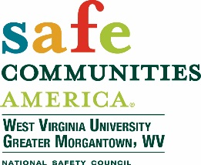



hosted by
West Virginia University Injury Control Research Center
West Virginia UniversityGreater Morgantown Safe Communities Initiative

