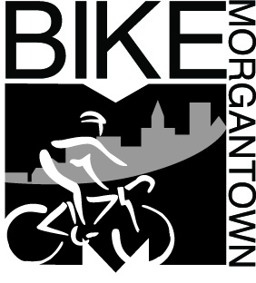
Morgantown Bicycling Plan

Vision | All Morgantown residents can enjoy bicycling safely and fearlessly anywhere, anytime for any reason.
Goal | Bicycle use in Morgantown will continuously increase and bicycle crashes will continuously decrease.  By 2020, 5% of all trips in and through Morgantown will be made by bicycle; 1 in 20 vehicles on the streets will be a bicycle.
Objectives | Education | Educate bicyclists how to operate their bicycles as vehicles and educate motorists how to treat bicyclists as drivers of vehicles.
Objectives | Enforcement | Enforce traffic laws whose violations endanger bicyclists and discourage bicycling.
Objectives | Engineering | Remove roadway impediments to bicycle use and build appropriate improvements to make bicycling a safer and more attractive transportation mode than motor vehicle use.
Objectives | Encouragement | Provide amenities, rewards and support to citizens for riding their bicycles rather than driving their cars.
Objectives | Evaluation | Measure bicycle use and bicycling crashes and use the data to identify improvements.
Objectives | Equity | Treat bicyclists as equals to motorists in all city activities.
Initiatives | Specific prioritized projects to accomplish the objectives.

