BikeMorgantown 2010 Accomplishments
Pre-2010 Recap 1
Confident City Cycling Instructors 2
Confident City Cycling Classes 2
Driver Education 2
Video Spots 2
Newspaper Articles 3
Billboards 5
WVU Info Kiosks 6
Bumper Stickers 6
Mountaineer Yellow Pages Community Page 7
Downtown Bicycle Parking 8
Bicycle Route Map 8
Signage Plan 9
Appendix 13
Published Newspaper Articles 13
Mountaineer Yellow Pages Community Page content 26

Pre-2010 Recap
BikeMorgantown is the City of Morgantown’s program for making Morgantown WV a more bicycle friendly community. The Morgantown Municipal Bicycle Board created the BikeMorgantown program and participates in its implementation.

In 2006, the Morgantown Traffic Commission created the 17-member Bicycle Board. Shortly after forming, 11 Bicycle Board members completed the League of American Bicyclists (LAB) Road I course.

In 2007, the Bicycle Board identified 75 projects that could improve Morgantown’s bicycle friendliness. Also in 2007, Morgantown applied for the LAB Bicycle Friendly Community award and received valuable feedback that we combined with our project ideas. We sorted the projects into Education, Enforcement, Engineering, Encouragement and Evaluation, prioritized them and proceeded to implement high priority projects. Some of these projects included a bike route map, shared lane markings and downtown bicycle parking.

In 2009, the City of Morgantown won a WV Transportation Enhancement Program grant with which it created the Confident City Cycling (CCC) education program. The CCC is based on the LAB SmartCycling program.

Following is a description of BikeMorgantown accomplishments from October 2009 through September 2010.

BikeMorgantown.com web site
BikeMorgantown.com is the informational hub of the Confident City Cycling program. The web site has been operational since March 2010. The website provides educational information, Confident City Cycling course schedule and on-line registration capability. Prior to the grant, education information was available through the Bike Board page http://www.morgantown.com/Confident-cycling.htm on the City of Morgantown website. The following figure shows the BikeMorgantown.com home page.

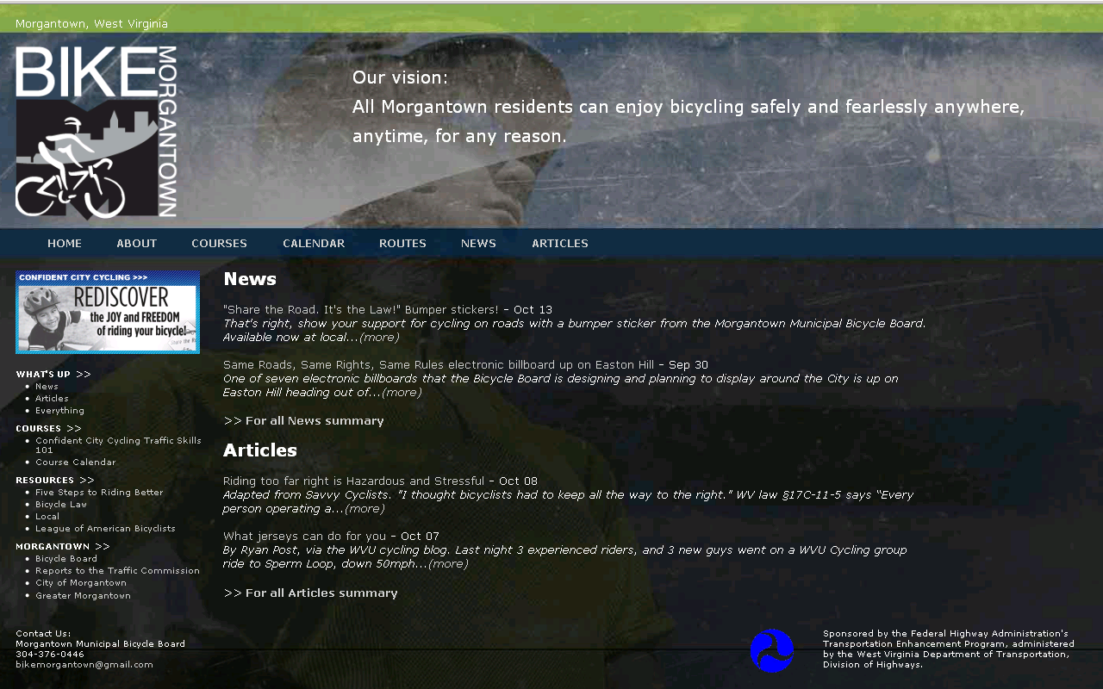

Confident City Cycling Instructors
Increased the number of Morgantown LAB Certified Instructors from 2 to 5.

Confident City Cycling Classes
Since October 2007, the Morgantown Bicycle Board’s League Cycling Instructors have taught 64 students Traffic Skills 101 in 14 deliveries of the course. Of those, participants 32 completed the course under the MEBEP TEP grant. Of those 14 deliveries, 5 were under the grant.

Driver Education
Developed and delivered Driver Education course entitled Share the Road, to one of the three Monongalia County School Driver Education instructors October 15. Course developed in collaboration with the League of Illinois Bicyclists includes video, 31-slide presentation plus pre-test and post-test paper documents. After the instructors complete the course, they have everything they need to deliver the course to high school students. The first scheduled delivery of the course by the trained driver ed instructor to high school students is November 2010.

Video Spots
Seven 15-second educational video spots are complete and are being broadcast regularly throughout each day by Comcast on networks Discovery, tbs, CNN, Comedy Central, CMT and Travel Channel as well as irregularly on random other channels. The spots are also broadcast regularly throughout every day on the Morgantown public access channel 15.

Spots can be viewed by following these links:
- Always Ride with the Flow of Traffic (http://www.youtube.com/watch?v=pR7XgBmiVkY)
- Obey Intersection Rules (http://www.youtube.com/watch?v=KWVsLkfKIH4)
- Always Scan, Signal, and Negotiate (http://www.youtube.com/watch?v=NP805DfuXYE)
- Treat Bicycles the Same as Other Vehicles (http://www.youtube.com/watch?v=NP805DfuXYE)
- Passing Cyclists Safely (http://www.youtube.com/watch?v=3JF_DM-3ICY)
- Yield to Traffic that has the Right of Way (http://www.youtube.com/watch?v=ZbBDPtRg7e0)
- Watch for Cyclists (http://www.youtube.com/watch?v=ldcStS2z_hs)
Closed-caption versions of the video spots are displayed on the video monitors at the WVU Personal Rapid Transit stations as well as on information kiosks around campus.

Newspaper Articles

Since April 2010, seven bicycling education articles have been published in the dominion Post and on the BikeMorgantown.com website. The Dominion Post has agreed to publish 12 more. The articles are published approximately the last Thursday of each month. The following table lists the articles and their publication dates. The actual articles are found at the end of this report. The articles are also published in the Articles section of BikeMorgantown.com.

Topic | Date Published
- May is National Bicycle Month | Apr 29, 2010
- Same Road, Same Rights, Same Rules | May 20, 2010
- ABC Quick Check | June 20, 2010
- Driving around Bicyclists | Jul 8, 2010
- Bicycling in Traffic | Aug 5, 2010
- Out and About on the Rail Trail | Sep 2, 2010
- Bicycling and Children | Oct 7, 2010
- Bicycling and Pedestrians
- Alternative Approaches: Bicycle Lanes, Road Share
- Civility on the Road
- Green Bicycling
- Healthy Bicycling
- Morgantown Bicycle Route
- Bicycling Around the World (including US)
- Bicycling Trips Around Morgantown
- Bicycle Friendly City Award
- Bicycle Groups in Morgantown
- Bicycling for Parents
- Commuting

Billboards
One electronic billboard was developed and displayed in the months of September and October 2010 on WV Rt. 119 heading north from Mileground Rd.

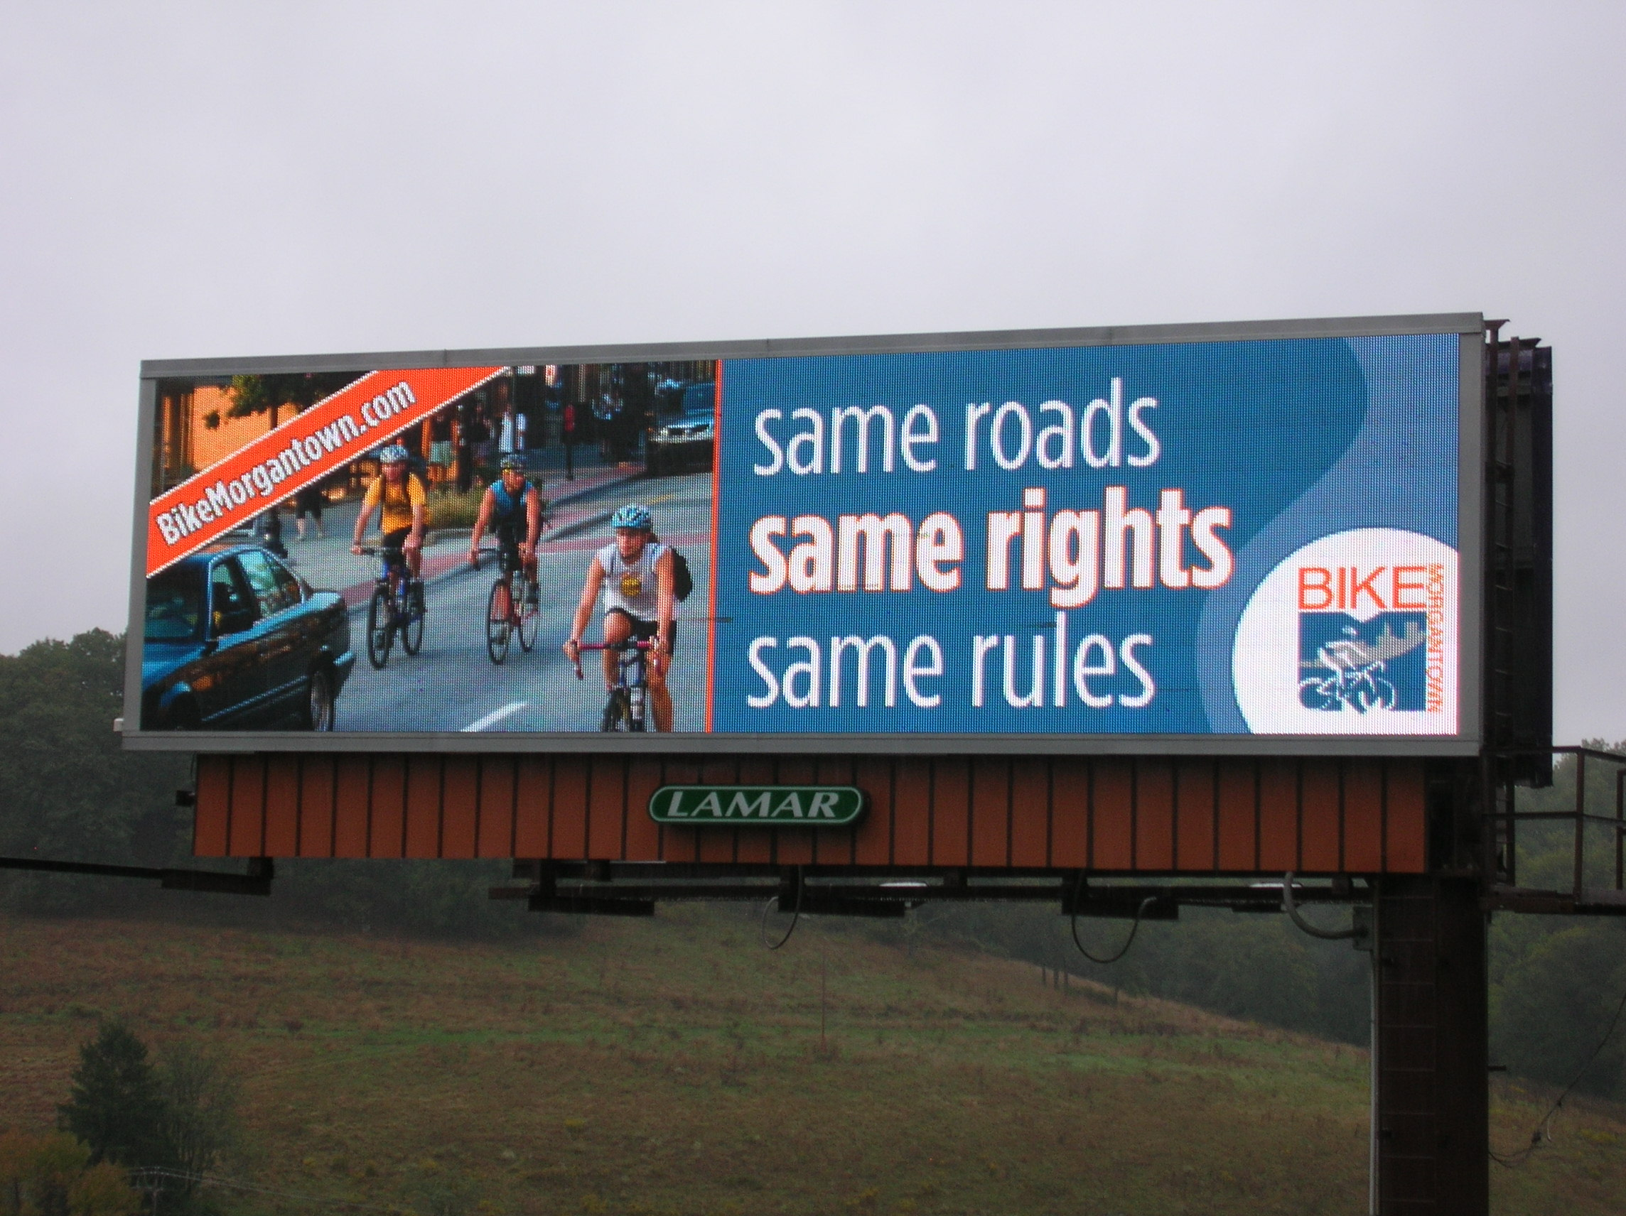

Six other messages will be developed in the coming months and displayed in the spring on two electronic billboards located on the Star City Bridge and the Mileground. Following are the messages that will be on the billboards:
• 4 Wheels, 2 Wheels, 1 Road: Let’s Roll Together
• Drive Nice, Bike Nice
• A Bicycle Friendly Morgantown is a (changing adjective) Community
Changing adjective: Healthier, Greener, Smarter
- For Confident City Cycling
CLICK
(downward pointing arrow)
BikeMorgantown.com

WVU Info Kiosks
WVU info kiosks located at PRT stations and in high pedestrian traffic campus buildings such as the Mountainlair will display the billboards in addition to the video PSAs discussed above.

Bumper Stickers
The Bicycle Board produced 1,000 bumper stickers intended to educate cyclists and motorists and to direct them to the BikeMorgantown.com for further educational information. The bumper stickers are available at City Hall, local bicycle shops and other locations frequented by bicyclists and motorists.

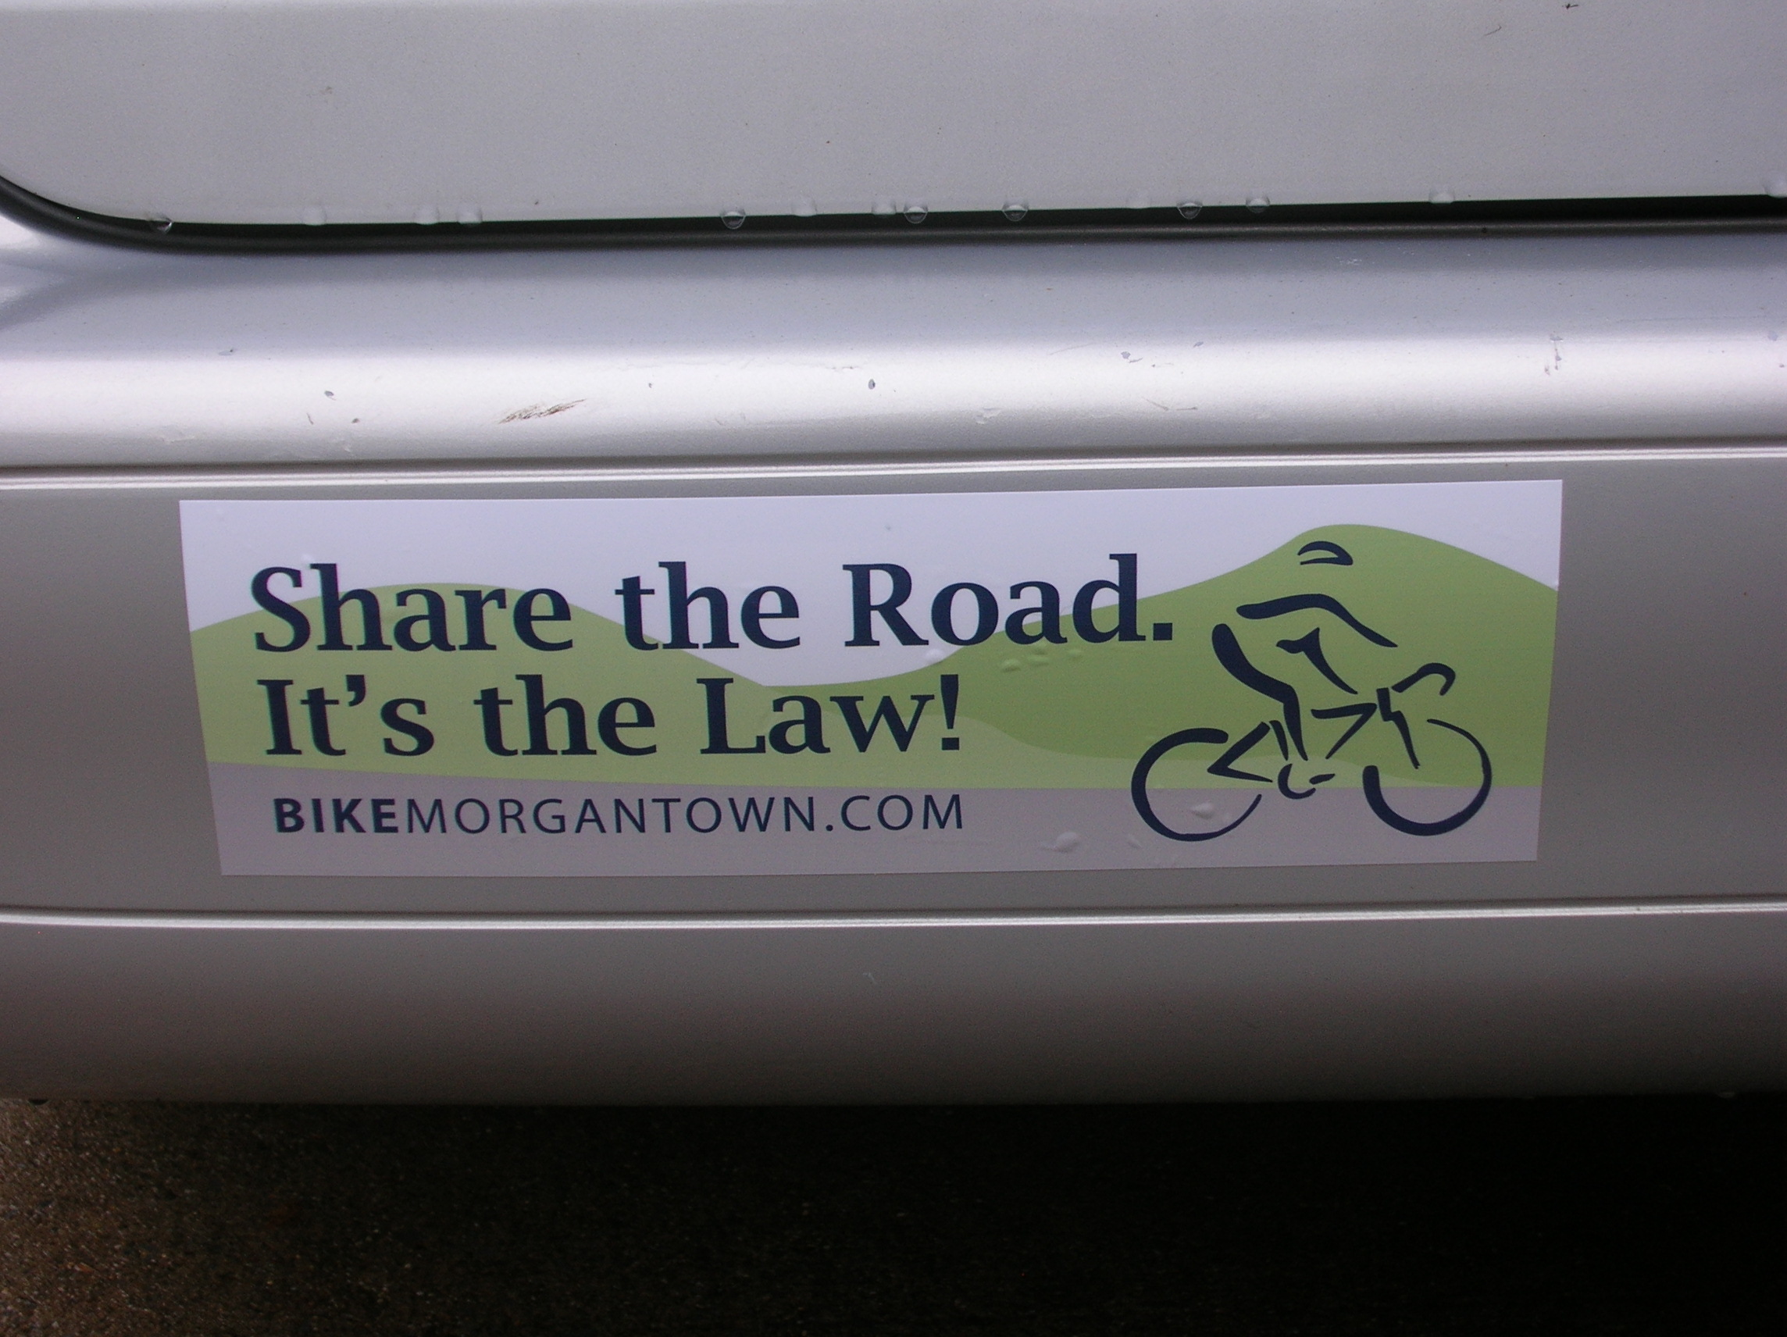

Mountaineer Yellow Pages Community Page
The Bicycle Board developed a full-page bicycling education “community page” for the Mountaineer Yellow Pages that will appear in the 2011 issue. See the Appendix below for an easier to read view of the content.

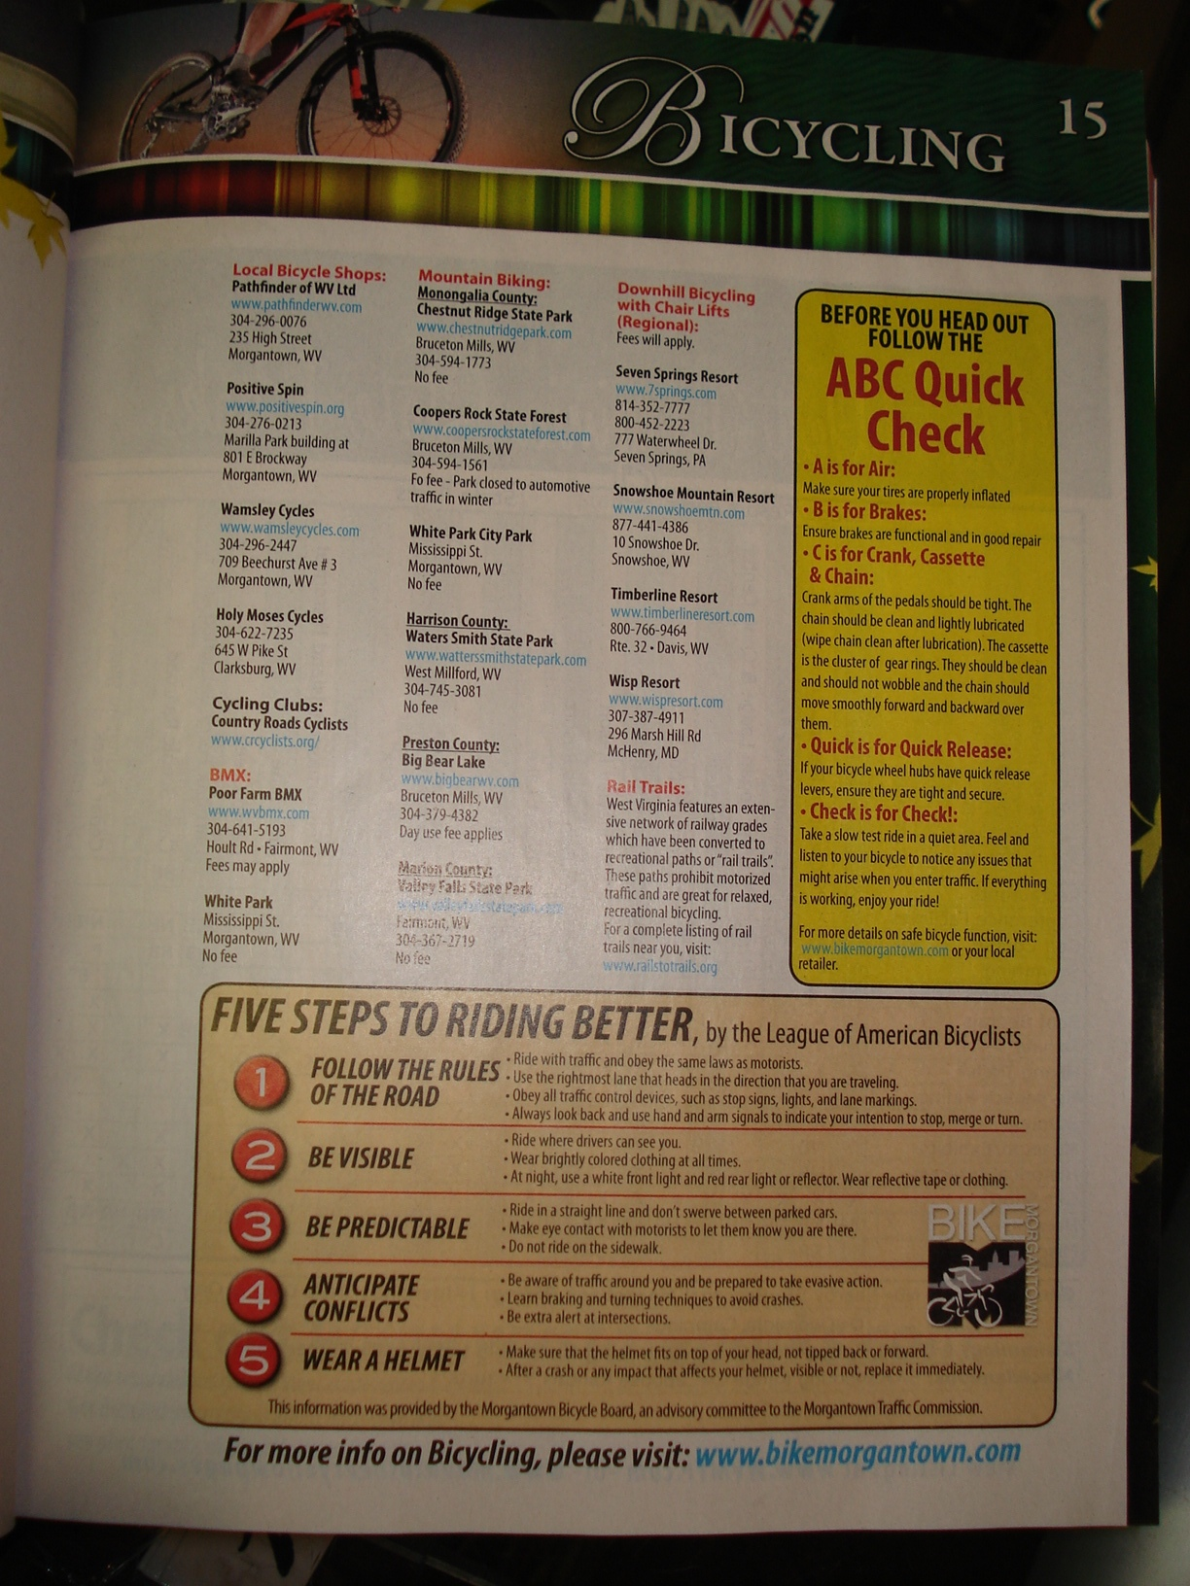

Downtown Bicycle Parking
23 parking racks have been received and are being installed downtown. The racks consist of a cast aluminum ring and a post. 18 of the rings are attached to existing parking meters on High Street and Walnut Street. Five rings will be attached to posts that will be installed on the north and south walkways of the Public Safety Center. Grant funds were not used for downtown parking.

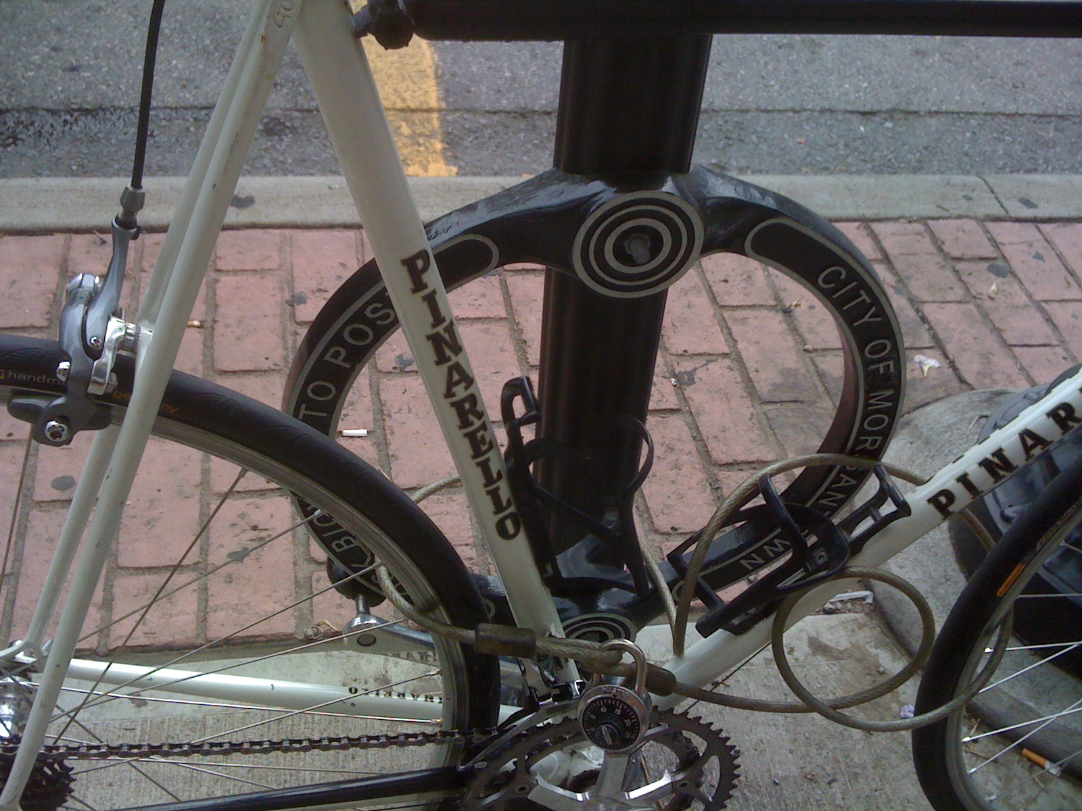

Bicycle Route Map
The Bicycle Board completed a Morgantown Bicycle Route map that shows some of the least challenging routes around town. The map also identifies more than 100 points of interest to cyclists. Bicycle Board members and two of their employers donated all effort and materials. The Board is currently identifying and pursuing means to get the map produced and distributed. The map will also be available electronically on the BikeMorgantown.com web site from which it can be downloaded to smart phones and GPS devices. Grant funds were not used to develop the bike route map.

Signage Plan
Beginning with a map that the Bicycle Board developed for a proposal to locate Shared Lane Marking and Bicycles May Use Full Lane signs throughout the City and the more recently completed Bike Route map, the Bicycle Board is in the process of locating on the map locations for Bike Route signs (D11-1) and Share the Road signs (W11-1 sign with W16-1 placard) as well as directional signs to points of interest to cyclists. Grant funds were not used to develop the signage plan. It is included in this report because it encourages residents to bicycle and educates them on destinations and routes.

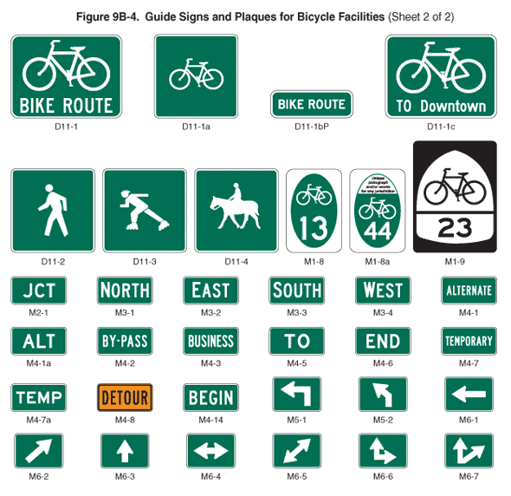
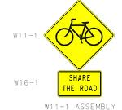

Following is a summary of the progress on the Bicycle Board’s proposal to install Shared Lane Markings and Bicycle May Use Full Lane signs.

On July 11, 2007, the Traffic Commission unanimously approved the Bicycle Board’s recommendation for the City to apply the Shared Lane Markings to specific roads in Morgantown.

On May 22, 2008 Paul Maddox, Secretary of the WV DOT, in a letter to Morgantown City Manager, Dan Boroff, authorized the City of Morgantown to apply Shared Lane Markings and to install Bicycles May Use Full Lane signs to guide bicyclists to the appropriate position on the roadway and to remind motorists that bicyclist have the same rights and are subject to the same duties as drivers of motor vehicles.

On June 13, 2008, Terry Hough requested the Bicycle Board to provide a map that she could include in the request for bids from contractors to install the Shared Lane Markings and Bicycles May Use Full Lane signs.

The Bicycle Board presented the map to the Traffic Commission at its December meeting.

In other cities such as San Francisco in which the Shared Lane Markings have been used, scientifically conducted studies showed that bicyclists are more likely to

- Drive in the direction of traffic flow,
- Drive on the right side of the road,
- Not drive on sidewalks, and
- Position themselves on the roadway to avoid colliding with opening doors of parked cars.

The studies also showed that when Shared Lane Markings are present, motorists are more aware of bicycles and give them a little more room when passing. Almost 2 years ago, Pittsburgh installed Shared Lane Markings on select streets and bicycle use has increased.

The new signs state that “Bicycles May Use Full Lane.” These signs are also in the new MUTCD. When the City sought WVDOH approval for the Shared Lane Markings, the WVDOH required a Bicycles May Use Full Lane sign to be placed along with the Shared Lane Markings. However, to minimize costs, the City negotiated to place the signs at the beginning of each run of Shared Lane Markings and in locations in which the sign would convey a clearer message than the Shared Lane Markings.

The Shared Lane Markings and Bicycles May Use Full Lane signs would be placed on Morgantown streets that bicyclists would use more if they knew they could ride on them. These streets include University Avenue, Patteson Drive, Van Voorhis Road, Collins Ferry Road, Beechurst Avenue, High Street, Spruce Street, Stewart Street, Willowdale Road, South University Avenue, Dorsey Avenue, Willey Street, Charles Avenue, Richwood Avenue, Rt. 7 in Sabraton, and Decker Boulevard.

In the process of approving the City’s plan for Shared Lane Markings, the WVDOH also agreed to install Share The Road signs on state routes leading into and around the City including Monongahela Boulevard, South University Avenue, the Mileground, and Greenbag Road.

Since the WVDOH approved our application, personnel changes led to their reconsidering their approval. An October 30, 2008 letter from Paul Maddox retracted his May 22 approval because the proposed Shared Lane Markings and Bicycles May User Full Lane signs were not in the 20003 MUTCD and the WVDOH has yet to adopt the 2009 MUTCD. When the WVDOH adopts the 2009 MUTCD, the Bicycle Board intends to replace Share the Road signs with Shared Lane Markings and Bicycles May Use Full Lane signs on roadways with speed limit less than 40 mp

Appendix

Published Newspaper Articles

ABC Quick Check

By Chip Wamsley

Bicycles are simple machines. However, because of their simplicity it is important that you give their mechanical systems a quick check before you ride. Taking a few minutes to perform the ABC Quick Check could prevent an accident and make your bike last longer.

A is for the air your tires need to perform properly. Use a pump with a pressure gauge to top off the air to the pressure printed on the tires sidewall. It is normal for tires to lose air between rides. After a winter in storage they may almost be flat. Starting at the valve, examine the tread around the tire for cuts, bulges, or worn places exposing the cords of the casing. Replace any tires that show damage.

B is for brakes to slow and stop your bike. The brake levers should pull smoothly and bring your bike to a safe and comfortable stop. The levers should stop when the brake pads grip the rim. At that point, there should be a thumb’s width space between the brake lever and handlebar. They should snap back when released. The brake pads should squarely contact the rim, not the tire. If worn down to the wear grooves, the brake pads should be replaced.

C is for the cranks, chain and cassette that make you go. A forward turn of the crank should make the chain rings spin in a straight line, not wobble side to side. Grasping a crank arm in each hand and pushing side to side should reveal no looseness. If the entire crank moves then the bottom bracket bearings need to be replaced or adjusted. If only one arm moves, it needs to be tightened. The chain should have a thin film of oil and be flexible. It should not be stiff, show rust, or be gummed up. Turning the crank forward should spin the rear wheel smoothly. Turning the crank backwards should make the chain move smoothly through the rear derailleur pulleys. If one or more links hops or kinks, your chain may be dirty, rusty, broken or bent.

Q is for the quick release levers that hold the wheels on and allow for easy wheel removal. They are not to be used like wing nuts and spun tight. Instead, tighten the release levers with the threaded block on the other side of the hub until the levers start to engage when they are half closed. Most levers are marked open and closed to indicate if they are in the proper position.

Check is for a slow test ride to make sure everything on your bike is working properly before starting out on your trip. Regular checks help you to become familiar with your bike when it’s running well. Checking your bike in a quiet traffic free location makes it easier to see or hear something out of order that you wouldn’t notice in traffic. If anything looked questionable when performing the ABC Quick Check, you should seek the help of a mechanic at your local bicycle shop.

Chip Wamsley is a member of the Morgantown Bicycle Board and owner of Wamsley Cycles

National Bike Month

By Frank Gmeindl

May is National Bike Month: a time to celebrate the joy and freedom of riding your bike.

May cycling weather may be the best. It’s also a good time to start using your bike instead of your car for those local trips around town. An ice cream downtown tastes a lot better after you rode there on your bicycle.

May 17-21 is National Bike to Work Week and Friday, May 21 is National Bike to Work Day. Biking to work can be really fun once you work out the details such as the route, transporting your clothes and cleaning up when you get there. Taking a test ride on a weekend can help iron out the details. Cycling with a co-worker can increase the fun and camaraderie. Most people that commute to work say they’re more alert and productive.
If you haven’t ridden in a while, May is a good time to start training. Even in our hilly area, cycling eventually becomes easier and more enjoyable the more we ride. If the hills are daunting, we’re blessed with many miles of smooth rail trails that can get you ready for the transition to more challenging cycling.

So pump up your tires, check your brakes, lube your chain, put on your helmet grab a water bottle and get out and ride. If your bike needs more work, now’s a good time to take it to your local bike shop for a spring tune-up.

Morgantown’s Confident City Cycling program can get you and your bike ready for riding anywhere, anytime for any reason. You can take a full weekend course that includes such topics as selecting and fitting a bike; basic maintenance; shifting gears; basic handling skills; riding in traffic and avoiding crashes. Or, 6 pm every Monday evening, you can attend a 1-hour session on one of these topics and then join in a leisurely ride. See www.BikeMorgantown.com for topics and dates.

A WV Transportation Enhancement grant makes Morgantown’s Confident City Cycling program possible. The Morgantown Municipal Bicycle Board adapted the program from the League of American Bicyclists’ Smart Cycling program. The Bicycle Board advises the Morgantown Traffic Commission.

On Sunday May 2, the Country Roads Cyclists and the Monongalia Bicycle Club kick off National Bike Month with the 35th annual Appalachian Spring Spectacular bicycle ride that includes 20, 40 and 60 mile rolling scenic road rides with refreshment stops along the way and a pasta feast afterward. The ride starts at 9 am at the Wharf Street Parking garage. Registration opens at 8. The ride is $5 and the feast $7.

Saturday, May 1 is the Appalachian Spring Spectacular Bonus Ride. This one is a bit harder and longer: 85 miles and 7,000 feet of climbing. The Bonus Ride starts at the Monongalia County Courthouse at 9 am. There is no fee.

Frank Gmeindl
Chairman, Morgantown Municipal Bicycle Board
League of American Bicyclists Certified Instructor #1703
www.BikeMorgantown.com

Same Roads, Same Rights, Same Rules

By Frank Gmeindl

Bicyclists have the same rights to the road as motorists. Bicyclists must also obey the same rules as motorists. Both WV (17C-11-2) and Morgantown (373.02(a)) laws state, “Every person riding a bicycle upon a roadway shall be granted all of the rights and shall be subject to all of the duties as the driver of a vehicle”.

When bicyclists operate their bicycles as vehicles, motorists are less likely to run into them. Operating a bicycle as a vehicle means obeying the rules of the road such as driving with traffic, stopping for stop signs, signaling turns and merges, yielding right of way, and choosing appropriate lane position. When bicyclists act as drivers of vehicles, they make themselves most visible and predictable. When cyclists are visible and predictable, motorists are more likely to treat them as drivers of vehicles and not run into them.

When bicyclists ride too far to the right, motorists may try to pass them when it is not safe to pass. Bicycles are narrower and usually slower than motor vehicles. While being narrow is often an advantage, sometimes being narrower can get a cyclist into trouble. On our narrow roads, cyclists sometimes ride too far to the right thus encouraging motorists to try to pass when it’s not safe to pass.

Some motorists will try to pass a cyclist even when they have to cross the center line and can’t see far enough ahead to ensure that the oncoming lane is clear. Consequently, they run the cyclist off the road, force on-coming traffic off the road or cause a collision. When we come up on a school bus, a construction vehicle or a farm tractor in the roadway, we usually wait until it’s clear to pass. We must do the same for bicycles.
WV law (17C-11-3(a)(1)) also requires drivers to pass at a safe distance. While WV doesn’t define how much distance is safe, many states specify that motorists must allow at least 3 feet space between their vehicle and a bicycle when passing.

Morgantown is hilly and our roads are narrow. If all our uphill lanes were wide enough (at least 14 feet) motor vehicles could pass bicycles without crossing the center line or without having to wait. Since our roads are narrow, we must remember not just that the law grants bicyclists the same rights to the road as motorists but that bicyclists are also citizens of our community who have families, jobs and other commitments and must get around for the exact same reasons as motorists.

Frank Gmeindl
Chairman, Morgantown Municipal Bicycle Board
League of American Bicyclists Certified Instructor #1703
http://www.bikemorgantown.com

Bicycling in Traffic

By Frank Gmeindl and Marilyn Newcome

Bicycling in traffic doesn’t have to be scary. When bicyclists drive their bicycles as vehicles, they are most visible and predictable and other competent drivers know how to treat them.

Bicyclists have the same rights to the road as motorists. Bicyclists also have to obey the same, rules such as driving on the right hand side of the road, stopping for stop signs, signaling turns and yielding right of way.

Bicycling in traffic requires some special skills needed to safely interact with cars on the road. Riding in traffic, a bicyclist needs be able to start and stop smoothly, ride straight while scanning for traffic around you, and give clear hand signals if you want to move sideways, turn, or stop.

Since bicycles are narrower than cars, cyclists can choose from many lateral positions in the lane. Choosing the correct position in a lane can prevent confusing and angering motorists.

Bicycles are usually slower than cars so bicyclists usually ride to the right side of the lane. However, there are times when riding to the right of the lane can confuse other drivers. For example, when making a left turn, going straight through an intersection or passing other vehicles, cyclists should signal and move left into the lane to communicate their intentions to other drivers.

Consider a left turn. If a cyclist wants to make a left turn, he or she should make the turn from the left side of the lane. Making a left turn from the right side of the lane could result in getting hit from behind by an overtaking vehicle. To move from the right side of the lane to the left side of the lane, the cyclist should scan beside and behind, give the appropriate hand signal and if another vehicle is occupying the space into which the cyclist wants to move, negotiate with the driver until he or she indicates by slowing down that they’re yielding the space for the cyclist to move left.
Similarly, when going straight through an intersection, if a cyclist stays to the right side of the lane, he or she risks a driver overtaking him or her and then turning right in front of him or her. This is called a “right hook”. To avoid a right hook, at a sufficient distance from the intersection, the cyclists should scan beside and behind, signal that he or she is going to move farther left in the lane, negotiate with any drivers that may be occupying that space, and then move into the middle of the lane to go through the intersection. Once through the intersection, the cyclist can move back to the right side of the lane.

Even when the cyclist is most visible and predictable, he or she may need to stop or make a sharp turn very quickly to avoid another vehicle that cuts in front of him or her. For example, if a motorist cuts off the cyclist by pulling out of a driveway or side street into the path of the cyclist, he or she may have to stop suddenly. To stop in the shortest possible distance, firmly apply both your brakes, front more than back; shift your weight to the rear and lower your torso to avoid skidding or going over the handlebars.

If a motorist passes a cyclist and then cuts right in front of him or her or if a motorist makes a left turn right in front of the cyclist, he or she may have to make a quick turn to avoid colliding with the car. Making the quickest turn possible actually involves first turning your handlebars opposite the direction you want to go to make the bike lean and then leaning into the turn and turning into the direction you want to go. Practicing these crash avoidance maneuvers makes them available when needed.

Being able to handle your bike, obeying the laws and being most visible and predictable prevents most crashes but if a crash happens, wearing a helmet and gloves can reduce injury.
Bicycling in traffic requires more knowledge and skill than driving a car. Bicycling in traffic with the knowledge and skills that you can learn in Morgantown’s Confident City Cycling program can transform what seems scary to some of us into a safe and enjoyable experience.

Frank Gmeindl and Marilyn Newcome are League of American Bicyclists Certified Instructors. They are also members of the Morgantown Municipal Bicycle Board.

Driving Around Bicycles

By Frank Gmeindl

Driving around bicycles can be frustrating. Having to wait behind a cyclist slowly climbing up one of Morgantown’s notoriously steep and narrow roads probably won’t make your day. For Morgantown cyclists, having cars lined up behind you sometimes blowing their horns, sometimes even yelling at you and then passing you so close you can feel the heat from their engines can be pretty scary.
Morgantown’s roads probably won’t get flatter, wider or straighter so how can we improve the ways in which cars and bicycles share the road?

Pennsylvania, West Virginia and Morgantown laws grant bicyclists the same rights to the roads as motorists and subject them to the same rules. If motorists treat cyclists as drivers of vehicles and if cyclists act as drivers of vehicles, driving around them should be no more troublesome than driving around other slow moving vehicles such as school buses, delivery trucks, construction equipment or farm vehicles.

When the road is too narrow for cars and bikes to travel safely side by side, it’s safest for the bicyclist to ride near the center of the lane. The WV Driver Licensing Handbook says, “When passing a bicyclist, slow down, make sure he is aware of you and leave plenty of room between him or her and your vehicle. If there is no room to pass and traffic is approaching, wait until traffic has gone by before passing.” Fifteen states have passed a rule that requires cars to leave a minimum of 3 feet between the car and bicycle while passing.

There is no need to blow your horn when passing a bicyclist. Blowing your horn can startle a cyclist and cause him or her to weave into your path.
Be extra watchful for bicycles. They’re narrower than cars and can be hard to see. Because they’re narrow, their speed can be hard to judge when they’re approaching you. On level roads and especially down hills they can be traveling a lot faster than you think. Before you pull out in front of them or turn in front of them, be sure you’re not going to cut them off.

When turning left at an intersection, yield to an oncoming bicyclist just as you would yield to an oncoming motorist.

Some cyclists will ride as far to the right of the lane as possible even when they intend to travel straight through an intersection or straight past a driveway. Before making a right turn onto a street or driveway, look right to be sure you’re not going to cut off a cyclist who’s beside you on your right.
In inclement weather give cyclists extra room. Visibility is usually reduced and stopping and turning require more room for both you and the bicyclist.
Watch out for road hazards such as potholes, glass and other debris. Give the cyclist space to maneuver around them.

When you have parked on a street, look behind you before you open your car door. A cyclist riding close to parked cars could crash right into it.

Especially watch out for children on bicycles. They often act unpredictably. Expect the unexpected.

Treating bicyclists as drivers of vehicles can minimize the chance of a serious accident. Remember that you are a lot bigger than the bicycle and you can easily inflict serious injury on the bicyclist.

Frank Gmeindl
Chairman, Morgantown Municipal Bicycle Board
League of American Bicyclists Certified Instructor #1703
http://www.bikemorgantown.com

Out and About on the Rail Trail

By Janel Bedard
The rail trail has reopened throughout Morgantown, following sewer work completion, and is packed with a variety of users. The rail trail is a great asset for city residents, providing several opportunities to interact with nature while getting in shape. The rail trail has become popular with different groups or users; therefore we all need to pay attention to safety issues so that it remains a pleasant and safe recreational resource for our city.
Pedestrians:
- When you are walking or running, always stay to the right hand side of the rail trail.
- Always walk with a friend.
- Walk no more than two abreast.
- Look both ways when you cross the trail.
- If you are out with your animals, keep your animals on a leash, under control, and to the right side of the trail.
- Be careful with your children. Children tend to wander or move unexpectedly, which may place them in the path of a bicycle or rollerblader.
- Teach your children to watch out for bicycles or other moving hazards. Teach your children to stay on the right hand side of the trail and to look both ways before crossing the trail.

Bicyclists:
- When you are out for a bike ride, respect not only the safety, but the experience of pedestrians on the trail. An unexpected “pass” by a bike will startle a pedestrian even if there is no collision.
- Do not use the rail trail for serious speed riding or large group fast riding.
- Unless passing, always stay to the right hand side of the trail.
- Keep speeds below 15 mph when there are pedestrians present. Slow down to walking speed when in areas of significant pedestrian density.
- Always let other users know you will be passing them with a friendly “on your left”, or a bell or other device capable of giving an audible signal.
- Keep your passing consistent and always pass on the left. If other users are in the left hand side of the trail politely say “on your left” and wait for them to move to the right side of the trail.

Rollerbladers:
- Rollerbladers may try to use the whole trail, but they must keep right and listen for faster users to pass.
All users are responsible for keeping their eyes and ears open when on the rail trail. While listening to music or the radio may be alluring, keep at least one ear open at all time to hear other users and remain safe.Following these simple guidelines can keep everyone safe on the rail trail this summer!
Janel Bedard is the WVU Cycling Club representative on the Morgantown Municipal Bicycle Board.

Bicycle and Children

By Alice Vernon

When our children were young, my husband introduced them to cycling. First we rode them on rear mount carriers attached to the back of our bikes until they were old enough to ride their own bicycle. These rear mount carriers have a weight limit of about 40 pounds. As they matured, we quickly learned there were other ways to cycle with our children. For the smaller child, a trailer pulled behind the rear of parent’s bike works great. The weight limit of many of these is 100 pounds. There are front mount carriers for the adult bikes available as well. These devices may increase the weight of the bike on the front or rear depending on the mount, so beware. There are scoot pedal-less style bikes for toddlers depending on the physical and mental readiness of the child. These bikes teach balance and are light, easy to maneuver and may eliminate the need for training wheels in the future. When the child is ready for their own bike with pedals, training wheels can be added if necessary. However, they will have to "relearn" to ride without them later.

The "Trail-a-bike", a device that attaches to the seat post of the adult bike, is a great way for the younger child to cycle with a parent. It allows them to participate in riding while not requiring them to pedal the whole time. The child can ride on the these devises without having to worry about bring able to balance on two wheels. The child must be physically able to sit and pedal on the bike seat by themselves.

Getting started depends on the physical development of the child. First, choose a proper fitting helmet and bike. A bike shop is a great place to start. Morgantown has two well versed shops, Pathfinder WV, Ltd and Wamsley Cycles. Keep the sessions fun and short at first while your child builds skills and fitness. Take them to a safe closed off area such as a park to learn how to start, stop, maneuver around objects mount and dismount their bicycles. Children as young as nine can learn to ride a bicycle in a straight line, stop at intersections and signal turns, but may lack the depth perception necessary to judge the speed of oncoming traffic.. If the child and parent decide to ride on the road with motor-vehicles, it is best for the parent to ride behind the child through traffic. A child on a bicycle can be often difficult to see by the motorist due to the height of their bike. Be sure to teach your child to be extra careful when crossing driveways and roadways from sidewalks.

It is beneficial for the child to take a cycling course. For information on "Smart Cycling" and "Cycling Skills for Children" courses contact Bike Morgantown at BikeMorgantown@gmail.com or call 304-376-0446. These classes teach both rules of the road and confident cycling on our roadways. Cycling on the road with your child helps promote cycling and fitness, provides transportation and freedom independence for the child, and helps children learn to read maps, and interact with pedestrians and motorists. If you don’t want to try riding on the roadways with your child, is not something you want to try, there are other wonderful places to bicycle with your children such as rail trails, bike paths, and mountain bike trails. Children love to explore and will really enjoy being in the woods. West Virginia offers both extensive rail trail systems and mountain bike trails.

Whatever type of riding you choose to do with your child, cycling can be a great way to spend time together, build fitness for both the parent and child, and teach cycling skills that will last into adulthood. Over the years it has been wonderful to continue to ride with our now adult children. Remember patience and fun are key!

Alice Vernon is an active cyclist and member of the Morgantown Municipal Bicycle Board

Mountaineer Yellow Pages Community Page content
Local Bicycle Shops:

Pathfinder of WV Ltd
pathfinderwv.com
(304)296-0076
235 High Street, Morgantown, WV

Positive Spin
positivespin.org
(304)276-0213
Marilla Park building at 801 E Brockway, Morgantown, WV

Wamsley Cycles
wamsleycycles.com
(304)296-2447
709 Beechurst Ave # 3, Morgantown, WV

Holy Moses Cycles
(304)622-7235
645 W Pike St, Clarksburg, WV 26301-2626

Cycling Clubs:

Country Roads Cyclists
crcyclists.org/

BMX:

Poor Farm BMX
wvbmx.com
(304)641-5193
Hoult Rd, Fairmont, WV
fees may apply

White Park
Mississippi St.
Morgantown, WV
no fee

Mountain Biking:

Monongalia County:

Chestnut Ridge State Park
chestnutridgepark.com
Bruceton Mills, WV
(304)594-1773
no fee

Coopers Rock State Forest
coopersrockstateforest.com
Bruceton Mills, WV
(304) 594-1561
fee no - park closed to automotive traffic in winter

White Park City Park
Mississippi St.
Morgantown, WV
no fee

Harrison County:

Waters Smith State Park
watterssmithstatepark.com
West Millford, WV
(304) 745-3081
no fee

Preston County:

Big Bear Lake
bigbearwv.com
Bruceton Mills, WV
(304)379-4382
day use fee applies

Marion County:

Valley Falls State Park
valleyfallsstatepark.com
Fairmont, WV
(304)367-2719
no fee

Downhill Bicycling with Chair Lifts (Regional):
Fees will apply.

Seven Springs Resort
7springs.com
(814)352-7777, (800)452-2223
777 Waterwheel Dr., Seven Springs, PA

Snowshoe Mountain Resort
snowshoemtn.com
(877)441-4386
10 Snowshoe Dr., Snowshoe, WV 26209

Timberline Resort
timberlineresort.com
(800)766-9464
Rte. 32, Davis, WV

Wisp Resort
wispresort.com
(307)387-4911
296 Marsh Hill Rd., McHenry, MD

Rail Trails:
West Virginia features an extensive network of railway grades which have been converted to recreational paths or “rail trails”. These paths prohibit motorized traffic and are great for relaxed, recreational bicycling.

For a complete listing of rail trails near you, visit railstotrails.org.

Before you head out, follow the ABC Quick Check:
A is for Air: Make sure your tires are properly inflated
B is for Brakes: Ensure brakes are functional and in good repair
C is for Crank, Cassette and Chain: Crank arms of the pedals should be tight. The chain should be clean and lightly lubricated (wipe chain clean after lubrication). The cassette is the cluster of gear rings. They should be clean and should not wobble and the chain should move smoothly forward and backward over them..
Quick is for quick release: If your bicycle wheel hubs have quick release levers, ensure they are tight and secure.
Check is for check! : Take a slow test ride in a quiet area. Feel and listen to your bicycle to notice any issues that might arise when you enter traffic. If everything is working, enjoy your ride!

For more details on safe bicycle function, visit bikemorgantown.com or your local retailer.

Five Steps to Riding Better

By The League of American Bicyclists

1. Follow the Rules of the Road
• Ride with traffic and obey the same laws as motorists.
• Use the rightmost lane that heads in the direction that you are traveling.
• Obey all traffic control devices, such as stop signs, lights, and lane markings.
• Always look back and use hand and arm signals to indicate your intention to stop, merge or turn.

2. Be Visible
• Ride where drivers can see you.
• Wear brightly colored clothing at all times.
• At night, use a white front light and red rear light or reflector. Wear reflective tape or clothing.

3. Be Predictable
• Ride in a straight line and don't swerve between parked cars.
• Make eye contact with motorists to let them know you are there.
• Do not ride on the sidewalk.

4. Anticipate Conflicts
• Be aware of traffic around you and be prepared to take evasive action.
• Learn braking and turning techniques to avoid crashes.
• Be extra alert at intersections.

5. Wear a Helmet
• Make sure that the helmet fits on top of your head, not tipped back or forward.
• After a crash or any impact that affects your helmet, visible or not, replace it immediately.

This information was provided by the Morgantown Bicycle Board, an advisory committee to the Morgantown Traffic Commission.

For more information on bicycling, please visit bikemorgantown.com

