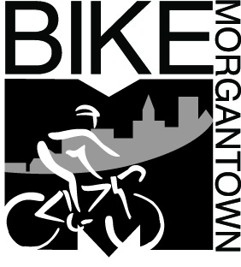 | Brian Ricketts  Morgantown Municipal Bicycle Board  491 Wilson Avenue  Morgantown, WV 26501  304-554-9450  Your e-mail address
May 2, 2016

Re: Morgantown Bike Month, May 2016

Good morning Rich:
My mane is Brian Ricketts and I am a member of the Morgantown Bicycle Board. The month of May has been designated by the city as Morgantown Bike Month and to celebrate, we will be hosting a number of events. We are looking for organizations who would like to help sponsor certain events through donations. We are looking for donations for the following events.
- Bike to School Day, May 4th
  - Snacks for kids. Coffee for adults
- Bike to Work Day, May 20th
  - Coffee and breakfast snacks
  - Gift certificates
  - Gear
  - Food or beer gift certificates
- Bike Rodeo, May 22nd (for kids to learn bike skills)
  - Gift Certificates

For your donations, you will receive the following
- Promotion of your organization on flyers and social media
- Increased traffic to your organization
- Helping give back to the Morgantown Community and supporting events that encourage people to live healthier and more actives lives.
Please, won’t you consider donating today. Contact Brian Ricketts at ricketts34wafa@gmail.com or call 804-241-8116 for more information and to donate.

Sincerely,
Brian Ricketts
Lead, Bike Month Committee
Morgantown Bicycle Board
www.bikemorgantown.com

