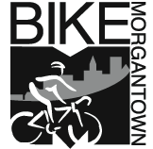

My name is Frank Gmeindl. I am a member of the Morgantown Municipal Bicycle Board, the Morgantown Traffic Commission and the Morgantown Monongalia Metropolitan Planning Organization Citizens Advisory Committee.

In 2012, the League of American Bicyclists awarded Morgantown a Bronze level Bicycle Friendly Community award. Morgantown is West Virginia’s first and only bicycle friendly community.

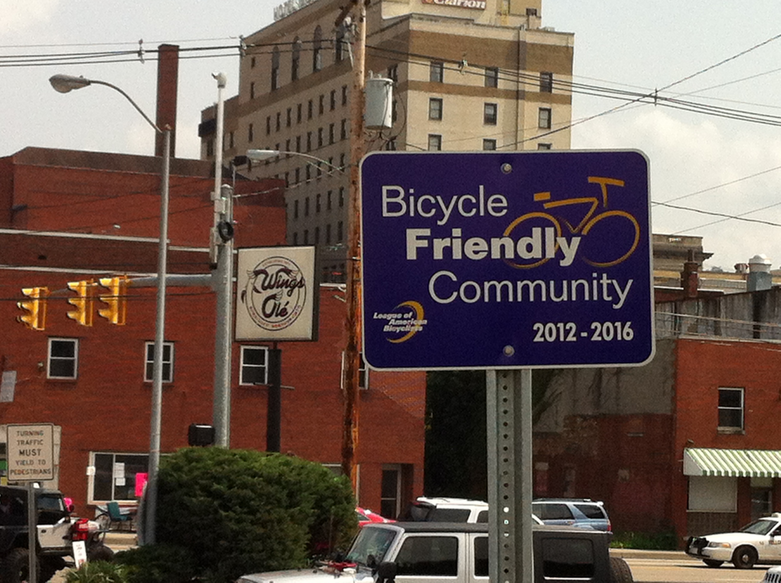

Morgantown’s Bicycle Plan is one reason that the League of American Bicyclists gave Morgantown this award. One planned action in the Bicycle Plan is to establish way-finding signage and roadway markings to guide bicyclists through the Morgantown bicycling network.

At a minimum, Morgantown needs way finding signs to direct bicyclists to the rail trail and to direct rail trail cyclists to Morgantown Bicycle Routes.

The Bicycle Board has reviewed the Arnett Muldrow “Visitor Wayfinding” report and observes that in its 76 pages, the word “bicycle” does not appear.

In the past few years, Morgantown has established a new Comprehensive Plan and a new Long Range Transportation Plan. For the first time, these plans were developed together by the entire Greater Morgantown Community. The Bicycle Plan is an integral part of these plans. These plans define what Morgantown residents want this community to become.

The Bicycle Board appreciates that Mainstreet Morgantown is interested in helping visitors find their way to downtown businesses. Numerous studies show that increased bicycling in downtowns increases business. The City of Morgantown has installed bicycle parking downtown. Now, we need to show bicyclists the best ways to get there from the neighborhoods.

At a minimum, Morgantown needs way finding signs to direct bicyclists to the rail trail and to direct rail trail cyclists to Morgantown Bicycle Routes.

February 5, 2014

